William Apess
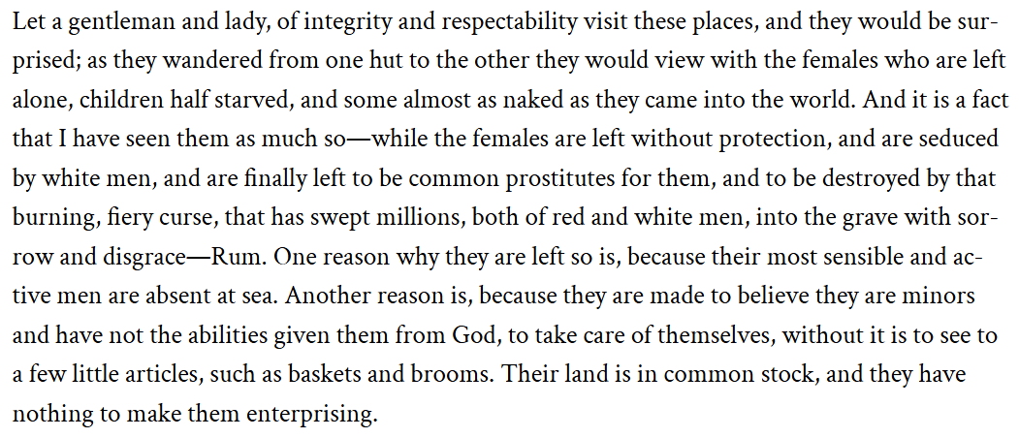

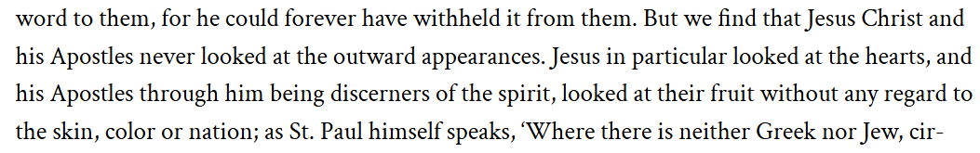

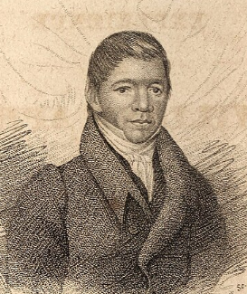
William Apess

Seneca Chief to George Washington
*Father is President George Washington

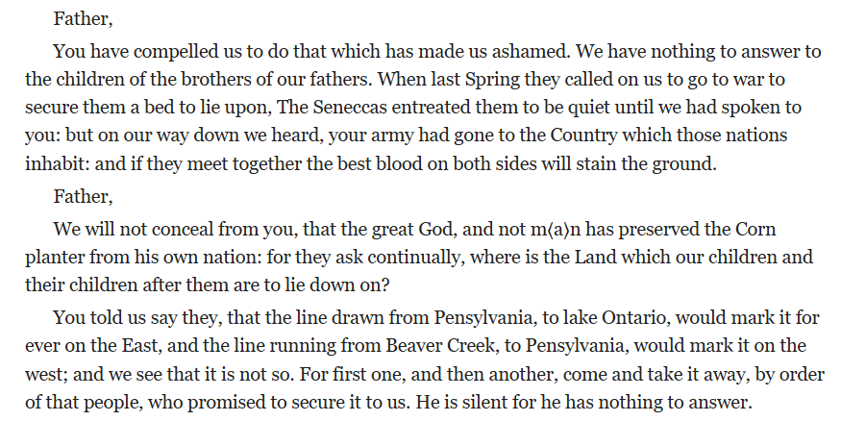

Seneca Chief to George Washington

Shawnee Chief Tecumsa

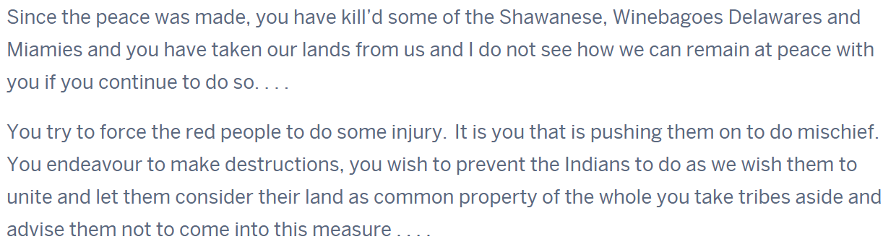

Shawnee Chief Tecumsa

Minavavana Chief of Chippewa
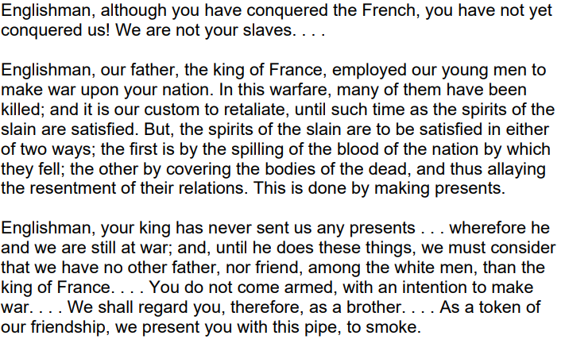

Minavavana Chief of Chippewa

Boarding School Memoirs
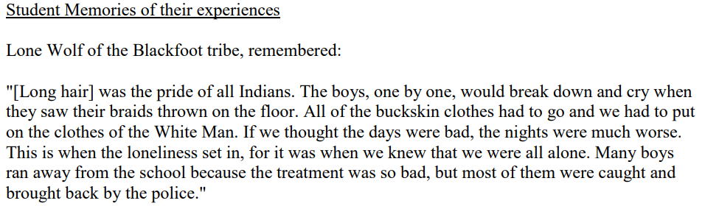

Memories from Native American “Boarding Schools”

*Boarding school was generally forced upon native children to separate them from their parents.

