Map of Ft Stanwix Treaty
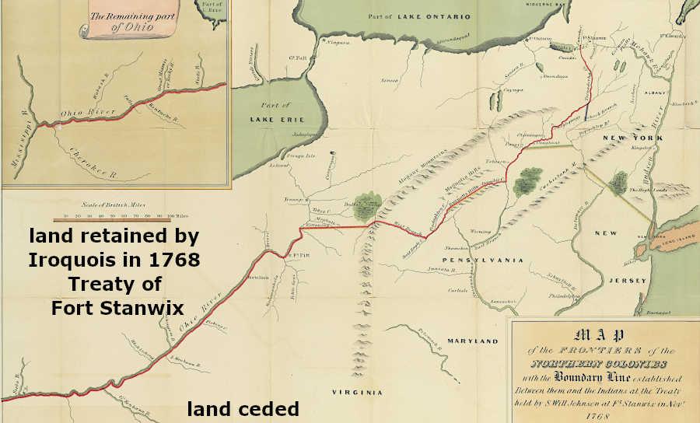

Civil Rights History
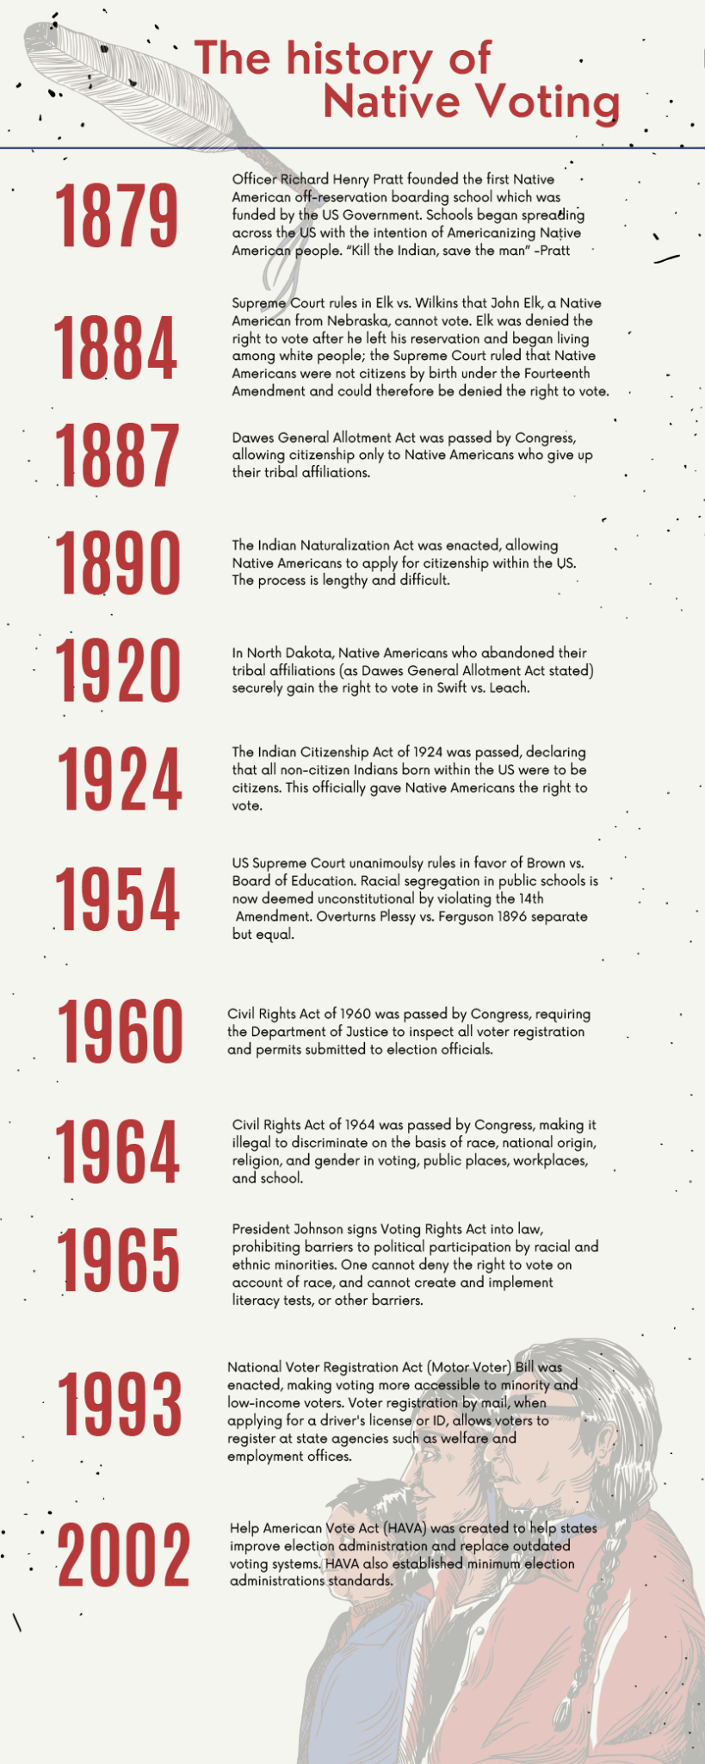
Source:https://nayapdx.org/blog/2022/10/31/
honoring-our-native-american-heritage/

