r/FridgeDetective
Directions: Below are images of the inside of people’s fridges. Circle the information that best applies to what is inside each fridge and what it says about the owner.
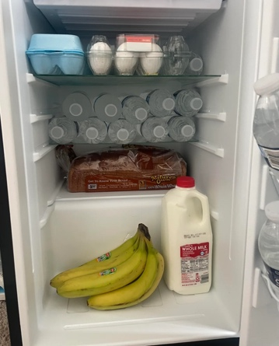  Fridge One:  How much food is in the fridge?  A lot Some Not Much  What does the fridge mostly have?  Ingredients to cook with Prepared Meals  The owner of the fridge is most likely:  A Parent A College Student | 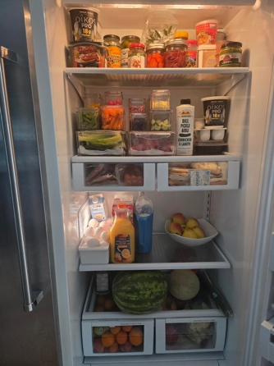  Fridge Two:  How much food is in the fridge?  A lot Some Not Much  What does the fridge mostly have?  Healthy food Unhealthy food  The owner of the fridge most likely:  Enjoys exercise Doesn’t enjoy exercise
Fridge Three:  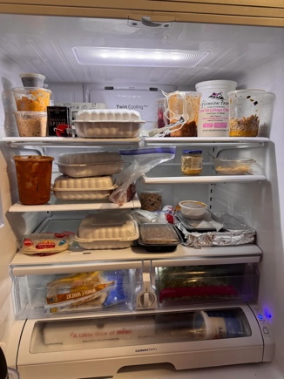  How much food is in the fridge?  A lot Some Not Much  What does the fridge mostly have?  Ingredients to cook with Prepared Meals  The owner of the fridge most likely:  Knows / doesn’t know how to cook | 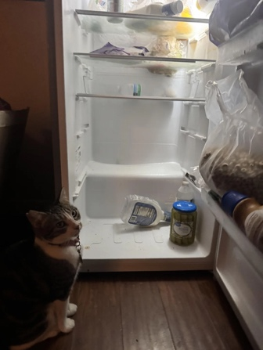  Fridge Four:  How much food is in the fridge?  A lot Some Not Much  How is the fridge organized?  Very organized Not organized  The owner of the fridge most likely:  Has a family Lives by themselves

My Fridge
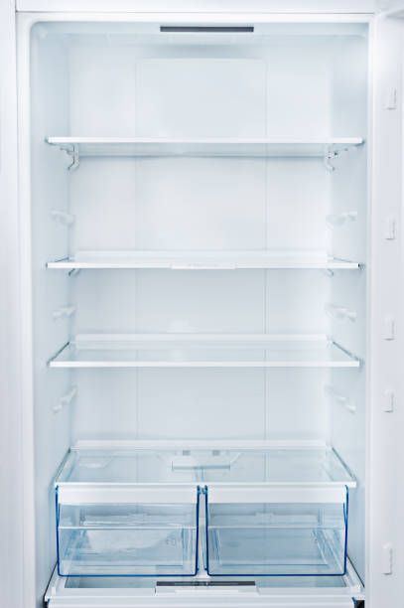
Direction: Draw or write AT LEAST FIVE objects that you would keep in your own fridge.

