r/FridgeDetective
Directions: Below are images of the inside of people’s fridges. Use your intuition to try to figure out what kind of individual the fridges may belong to and why you think that.
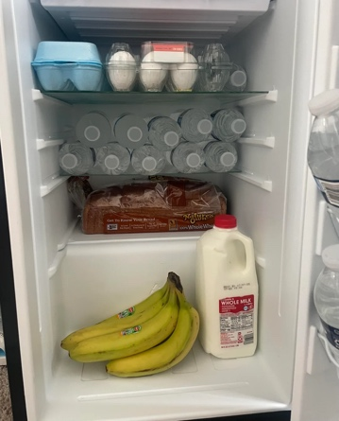  Fridge One:  Describe the type of individual this fridge may belong to:  Why do you think this fridge belongs to that kind of individual? | 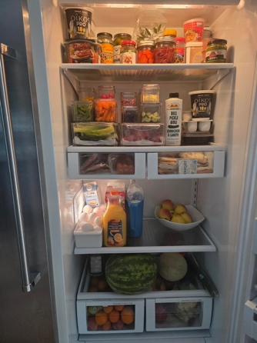  Fridge Two:  Describe the type of individual this fridge may belong to:  Why do you think this fridge belongs to that kind of individual?
Fridge Three:  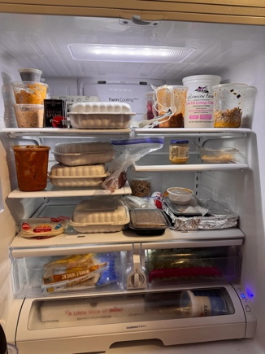  Describe the type of individual this fridge may belong to:  Why do you think this fridge belongs to that kind of individual? | 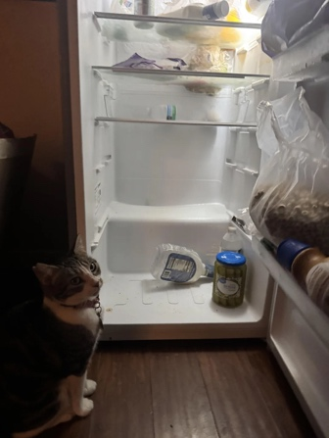  Fridge Four:  Describe the type of individual this fridge may belong to:  Why do you think this fridge belongs to that kind of individual?

My Fridge
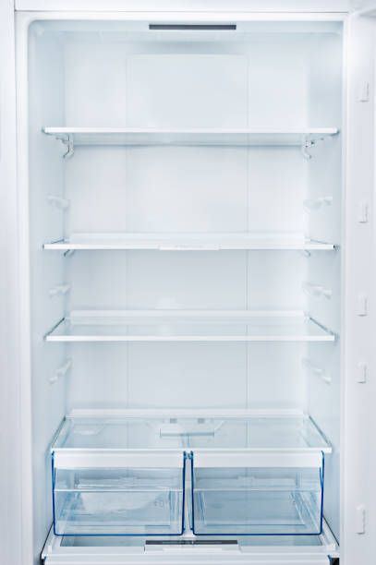
Direction: Draw or write AT LEAST FIVE objects that you would keep in your own fridge.

